The photo I chose is
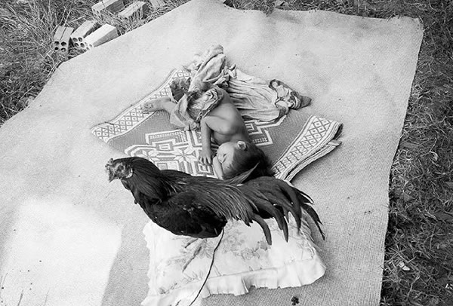

This is a photo of a baby laying on two blankets with a chicken standing on a pillow in front of the baby. the story told in this picture is I think a loving mother taking a picture of her baby sleeping and as Shes setting up the camera a chicken flies in front and lands mid shot the mother likes the spontaneity of the photo and keeps it the way it is, even though it was not intended that way.
One good thing about this photo is that it is framed nicely on the grass by the tarp and the blankets under the baby.
One thing I would change is where the chicken is, the baby has been placed in the center alluding that it should be the center of attention the chicken Infront of it blocks where your eyes go naturally. I would move the chicken behind the baby. I would also move the bricks that are in the top left corner. Lastly, I would back up to get the whole blanket in the photo
Overall, this photo is set up perfectly with the placement of the blankets and the angel and the baby. Just move the chicken.

