CLC 12 – Mentorship Selection Form

The Important Role of Mentors
Having a mentor in not only important, but it can be a powerful and rewarding experience. As part of your CLC Graduation Project, you will be asked to find a mentor(s) to support and guide you through completion of your project.

Mentorship is a relationship in which a more experienced or more knowledgeable person helps to guide a less experienced or less knowledgeable person. It is a learning and development partnership between someone with vast experience and someone who wants to learn. Mentors play a key role in helping you with career-life development, including planning, decision making, providing exposure to possibilities, and finding emerging
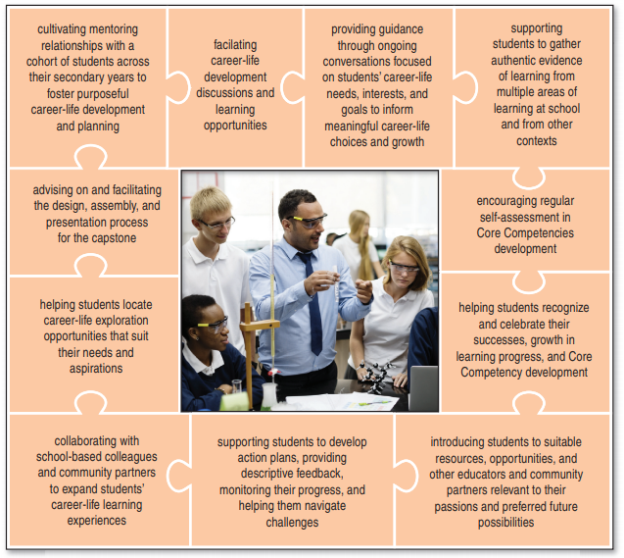
opportunities.

Choosing a Mentor
Choosing a mentor isn’t necessarily a difficult
task, but it should be something you put some
thought into.

A peer is someone who is about your age: a
classmate, friend or buddy; however, a
mentor is NOT the same thing as a peer. Your
mentor should be an adult that you trust,
e.g. teacher, family member, community
member; they must have some expertise or
knowledge in the area you are exploring for
your CLC Graduation Project; and they
should be able to give you feedback and
suggestions (in-person or via telephone,
email, skype, etc).

When choosing a mentor here are some
things to consider:
- Values: It is important to make sure
your values align with the person you
are considering as a potential
mentor. This will help build a better
relationship.
- Communication: You want to make sure the
person you have in mind can communicate with you in a way that is easy for you to understand.
- Willingness: This person must be willing to help and feel comfortable to readily share with you.
- Expectations: Ensure you define what you are looking for in the mentorship so that you and your potential mentor are on the same page, e.g. how much time you would like to meet with your mentor and how they can help you.
- Personality: Finding someone with a complementary personality to yours can help better develop your mentorship.

Next Step…
Once you have a mentor, you need to discuss what an ideal mentorship will be with your mentor. Will it be informal? How will you communicate with each other? You need to define the expectations of your mentorship with your mentor from the beginning. This mentorship will be an ongoing process, that is why it is important to have an open dialogue with them.
Mentorship Permission Form

You will need permission from your Mentor(s) and your Parent/Guardian. If you have more than one Mentor, please print another copy of this form and have it signed.
Please have each person sign this document.

Mentor
Name of Mentor (print first & last name): ____________________________________________

Relationship to Student (if applicable): ______________________________________________

I agree to be this student’s Mentor (Check one): Yes No

Contact Email: _____________________________________ Phone: ______________________

Mentor Signature: __________________________________ Date: _______________________

Parents/Guardian

Name of Parent/Guardian (print first & last name): ____________________________________

Relationship to Student: __________________________________________________________

I approve the Mentor my child has selected (check one): Yes No

Contact Email: _____________________________________ Phone: ______________________

Mentor Signature: __________________________________ Date: _______________________

