Darian, Logan & Luca
Wallace (Block 4)
June 07, 2021

Welcome to SUNCITY

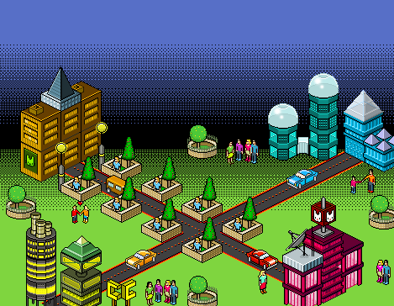

Welcome to SunCity. A small town with a big imagination. SunCity could be considered a town because of it’s small number of residents (1845) but it still has a big city feel. This is the best of both worlds and is a hidden gem kilometers away from any busy bustling city centre.

Legends:
- Brown buildings - town residences
- Yellow/green buildings: shopping center, grocery store, entertainment complex (movies, rinks)
- Blue buildings: water towers and food processing plant
- Pink buildings: K-12 school, town college and local office tower

VALUES:
In building SunCity, we considered what we value most. We value the modern lifestyle but in a small town setting, We want a close-knit community where everyone knows each other and where stability and natural growth is present. We have kept it smaller in size so that there is community bond that exists between the residents that live here. We are surrounded by grass and trees and just beyond the town borders are three clean water lakes that provide us with the water that we need. The greenery surrounding us will also help keep our air cleaner. Our town’s core values are all about family. All children, teens, and young adults attend the one school site in town and take part in a variety of extracurricular activities in our entertainment center. This is a fun, supportive community hidden away from the hectic go-getters that live in the city but still identifying with the modern lifestyle that many people enjoy.

COLORS:

Green, Yellow, Blue, Pink

We chose green for one of our main city colors because green reminds us of nature, growth, and the creation of life. We want a lot of greenery bordering our city and so we have planned to have lots of grass, trees, and plants surrounding it.

We selected pink and yellow as two other main city design colors because yellow is the color of sunshine and happiness and pink represents caring and love. Yellow is a fun, bright, feel-good color and, in this town, the sun is shining almost every day. The people in this town love the sunshine and they look forward to enjoying the sunny days. Pink fits in well with our family driven community.

We also chose blue as a main color for our town as it represents water and gives us a feeling of calm and relaxation. Water is a crucial part of life and survival and water and sunshine give us growth so having green, blue, pink and yellow as our main town colors show that we want a positive, calm, happy environment for people to live in.

Communication Reflection
I was in a group with Luca and Logan and we worked hard on the design of our town. We began by drawing an outline on paper of what we would like our town to look like. We then went over the core values that were important to us and what we wanted to have as a value system for our town. We discussed whether we wanted a smaller town or larger city and we each thought about how the planning should go. At this stage, we split up the work and each took on a part of the project. I created the basic town design and the three of us then spent time bringing our work all together into one final design. The citycreator was a bit difficult to use as it was a fairly small space to work with and it limited what we could pick for our town setup. We did the best we could and I am happy with the outcome.

