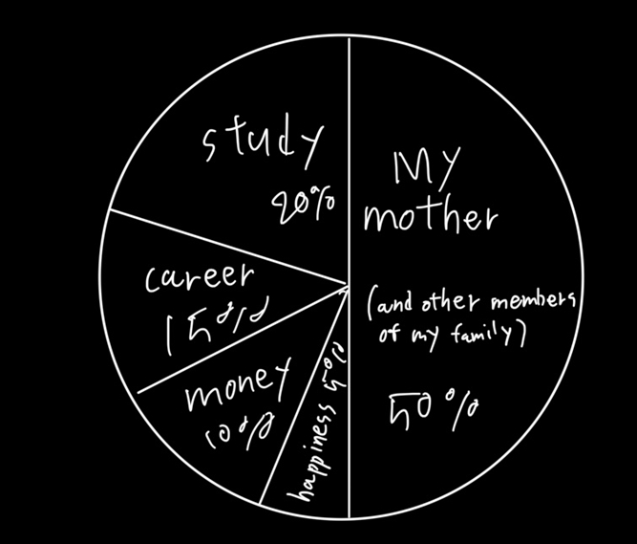
1.My mother (and other members of my family) [50%] :
Whenever I am having a hard time, my family gives me strength. Among them, I think that I was able to experience and learn many things because my mother helped me achieve my dream.

2.study [20%] : Because I have to study to get a job.

3.career [15%] : Because I have to get a career to make money

4.money [10%] : Because I need money to live happily

5.happiness [5%] : Because if I’m unhappy, I don't want to live

