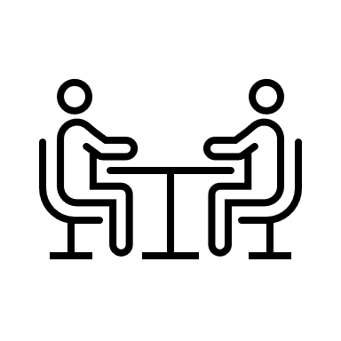
Interview Preparation Brainstorm Sheet

An interview is the final and most important part of the hiring process. You and the employer will have a conversation to get to know each other better. The employer wants to find out more about you and make sure you’re the right person for the job. You also have an opportunity to find out if the workplace is right for you.

For each of the categories below, brainstorm how you could make a good impression.

Physical Appearance/Hygiene

- Clean clothing that is appropriate
- Brushed hair, showered, “cleaned yourself up”

Body Language/Manners
- Open body language (not stiff)
- Walk in confident
- No slouching, straight posture

Speaking/Tone of Voice
- Clear tone
- Avoid stuttering
- Confident, don’t sound hesitant
- Greet the employer (hello, handshake, wave, etc)

Preparation for the Meeting (getting there, what to bring, what to say, etc.)
- Practice possible interview questions
- Bring any documents the employer could possibly want/need
- Arrive on time, maybe even a bit early just in case

General ideas for making a good impression

